**Sales Performance Analysis Dashboard using Power BI**

**By**

**Name: Shantanu Anand**

**Email: shantanuanandvit@gmail.com**

**Abstract**

This study explores a data-driven approach to customer segmentation and rating analysis, leveraging transaction data on customer spending patterns, product ratings, and purchase trends. By applying advanced DAX calculations and Power BI visualizations, we aim to identify high-value customers, evaluate product performance, and track growth trends over time. Insights from this analysis will inform strategic decision-making, allowing for targeted marketing, improved product management, and enhanced customer satisfaction.

**1. Introduction**

Understanding customer behavior and product performance is essential for businesses aiming to maintain a competitive edge. Customer segmentation enables companies to tailor strategies by identifying distinct groups of customers based on spending and satisfaction levels. This proposal outlines an approach to analyze customer data using Power BI, applying DAX functions for segmentation, ranking, and growth analysis. Key metrics such as Total Spend, Customer Rank, and Weighted Rating provide actionable insights that guide strategic initiatives to enhance both customer engagement and profitability.

**2. Objectives**

The analysis is structured around the following core objectives:

1. **Customer Segmentation**: Classify customers into spending tiers (Platinum, Gold, Silver) for tailored engagement.
2. **Rating Analysis**: Combine product ratings with sales volume to identify top-performing products.
3. **Sales Trend Analysis**: Track Year-over-Year (YoY) Sales Growth to identify growth trends.
4. **Product Popularity Assessment**: Use Weighted Rating to prioritize high-demand, high-rated products for stock and marketing.

These objectives provide a holistic view of customer value, product satisfaction, and sales dynamics.

**3. Data Analysis Approach**

This approach includes creating calculated columns and measures using DAX in Power BI to address each objective:

**Task 3: Sales and Rating Analysis**

1. **Total Sales (Measure)**
   * **Formula**: Total Sales = SUM(Sales_Orders[Sales_Amount])
   * **Purpose**: Aggregates total sales to analyze revenue generation per customer or product.
2. **Previous Year Sales (Measure)**
   * **Formula**: Previous Year Sales = CALCULATE([Total Sales], SAMEPERIODLASTYEAR(Sales_Orders[OrderDate]))
   * **Purpose**: Calculates sales from the previous year to enable year-over-year analysis.
3. **YoY Sales Growth (Measure)**
   * **Formula**: YoY Sales Growth = DIVIDE([Total Sales] - [Previous Year Sales], [Previous Year Sales], 0)
   * **Purpose**: Determines year-over-year growth, identifying trends in business expansion or contraction.
4. **Total Rating Points (Measure)**
   * **Formula**: Total Rating Points = SUMX(Sales_Orders, Sales_Orders[User_Rating] * Sales_Orders[Quantity])
   * **Purpose**: Combines ratings with sales volume to assess product popularity and customer satisfaction.
5. **Profit (Column)**
   * **Formula**: Profit = Sales_Orders[Sales_Amount] - Sales_Orders[Product_Details.Cost_Price] * Sales_Orders[Quantity]
   * **Purpose**: Calculates per-order profit, helping assess profitability by transaction.
6. **Profit Margin (Column)**
   * **Formula**: Profit Margin = DIVIDE(Sales_Orders[Profit], Sales_Orders[Sales_Amount]) * 100
   * **Purpose**: Expresses profitability as a percentage, providing insight into margin efficiency.
7. **Discount Amount (Column)**
   * **Formula**: Discount Amount = Sales_Orders[Sales_Amount] * (Sales_Orders[Discount] / 100)
   * **Purpose**: Determines discount impact on revenue, supporting pricing and discount strategies.
8. **Net Sales (Column)**
   * **Formula**: Net Sales = Sales_Orders[Sales_Amount] - Sales_Orders[Discount Amount]
   * **Purpose**: Reflects effective sales after discounts, showing the net revenue per sale.
9. **Quantity (Column)**
   * **Formula**: Quantity = ROUND(DIVIDE(Sales_Orders[Sales_Amount], Sales_Orders[Product_Details.Cost_Price]), 0)
   * **Purpose**: Calculates the quantity sold by dividing sales by cost, rounded to the nearest whole number.
10. **Rating Category (Column)**
    * **Formula**:

DAX

Copy code

Rating Category =

IF(Sales_Orders[User_Rating] >= 4, "High",

IF(Sales_Orders[User_Rating] >= 3, "Medium", "Low"))

* + **Purpose**: Classifies products based on customer ratings, indicating product quality levels.

1. **Weighted Rating (Column)**
   * **Formula**: Weighted Rating = Sales_Orders[User_Rating] * Sales_Orders[Quantity]
   * **Purpose**: Combines ratings with sales volume for a score that reflects both popularity and customer satisfaction.

**Task 4: Customer Segmentation**

1. **Total Spend (Measure)**
   * **Formula**: Total Spend = SUM(Sales_Orders[Sales_Amount])
   * **Purpose**: Aggregates each customer’s spending for ranking and segmentation.
2. **Customer Rank (Measure)**
   * **Formula**: Customer Rank = RANKX(ALL(Customer_Info), [Total Spend], , DESC, Skip)
   * **Purpose**: Ranks customers by spending, identifying top contributors to revenue.
3. **Customer Expense (Column)**
   * **Formula**:

DAX

Copy code

Customer Expense =

IF([Total Spend] > 500, "Platinum",

IF([Total Spend] > 50, "Gold", "Silver"))

* + **Purpose**: Classifies customers into Platinum, Gold, and Silver tiers, aiding in customer-targeted marketing strategies.

**4. Methodology**

Our approach includes data preprocessing, calculated columns and measures in Power BI, and visualizations:

* **Data Import and Preprocessing**: Customer transactions, product details, and ratings data are imported into Power BI. Data transformations are applied to ensure consistency and relevance for segmentation and analysis.
* **DAX Calculations**: We created calculated columns and measures to achieve segmentation, ranking, and growth analysis. Each formula is optimized to avoid dependencies and circular references.
* **Visualizations**:
  + **Top Customers by Total Spend**: Bar charts show the highest spenders.
  + **Customer Segmentation (Platinum, Gold, Silver)**: Pie charts display customer distribution across segments.
  + **YoY Sales Growth Trend**: Line charts track growth over time.
  + **Product Popularity by Weighted Rating**: Scatter plots identify top-rated, high-demand products.

**5. Results Interpretation**

The DAX calculations and visualizations provide several key insights:

1. **Customer Insights**: Ranking and expense classification reveal high-value customers, informing loyalty strategies.
2. **Product Performance**: Weighted Rating highlights popular and well-rated products, supporting promotional efforts.
3. **Sales Trends**: YoY Sales Growth reveals seasonal patterns, guiding strategic decisions in business planning.

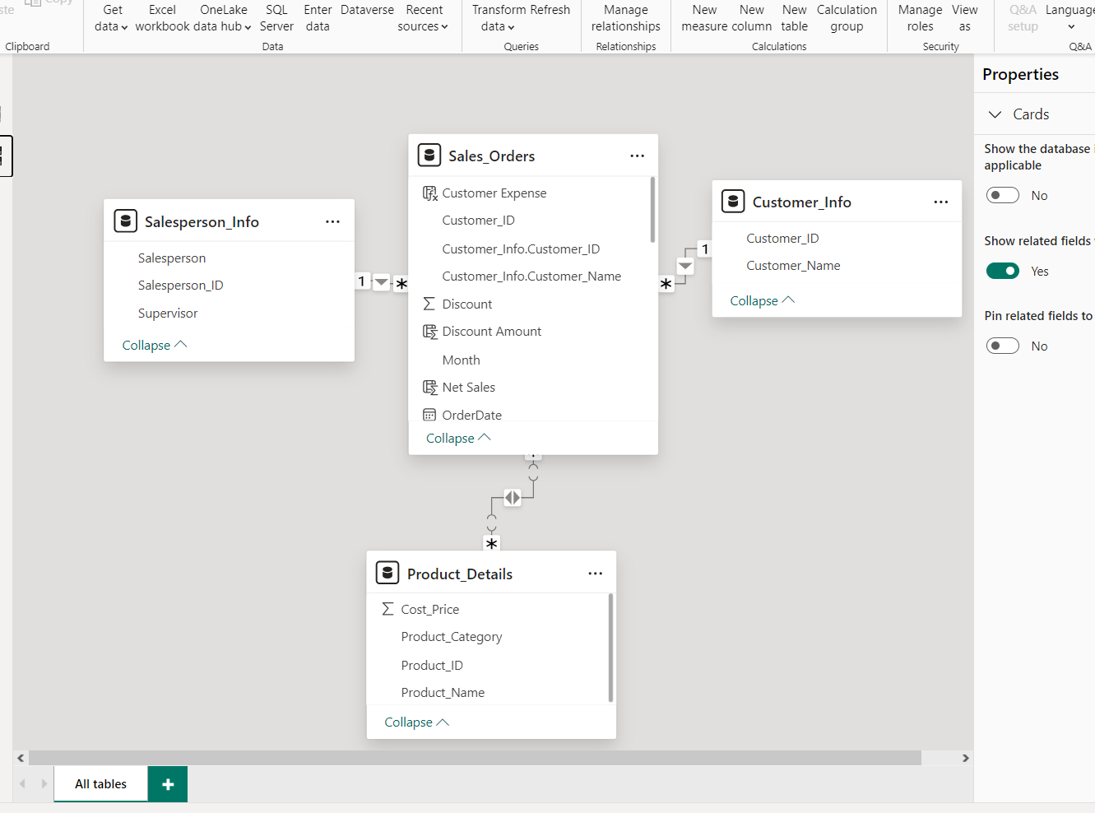

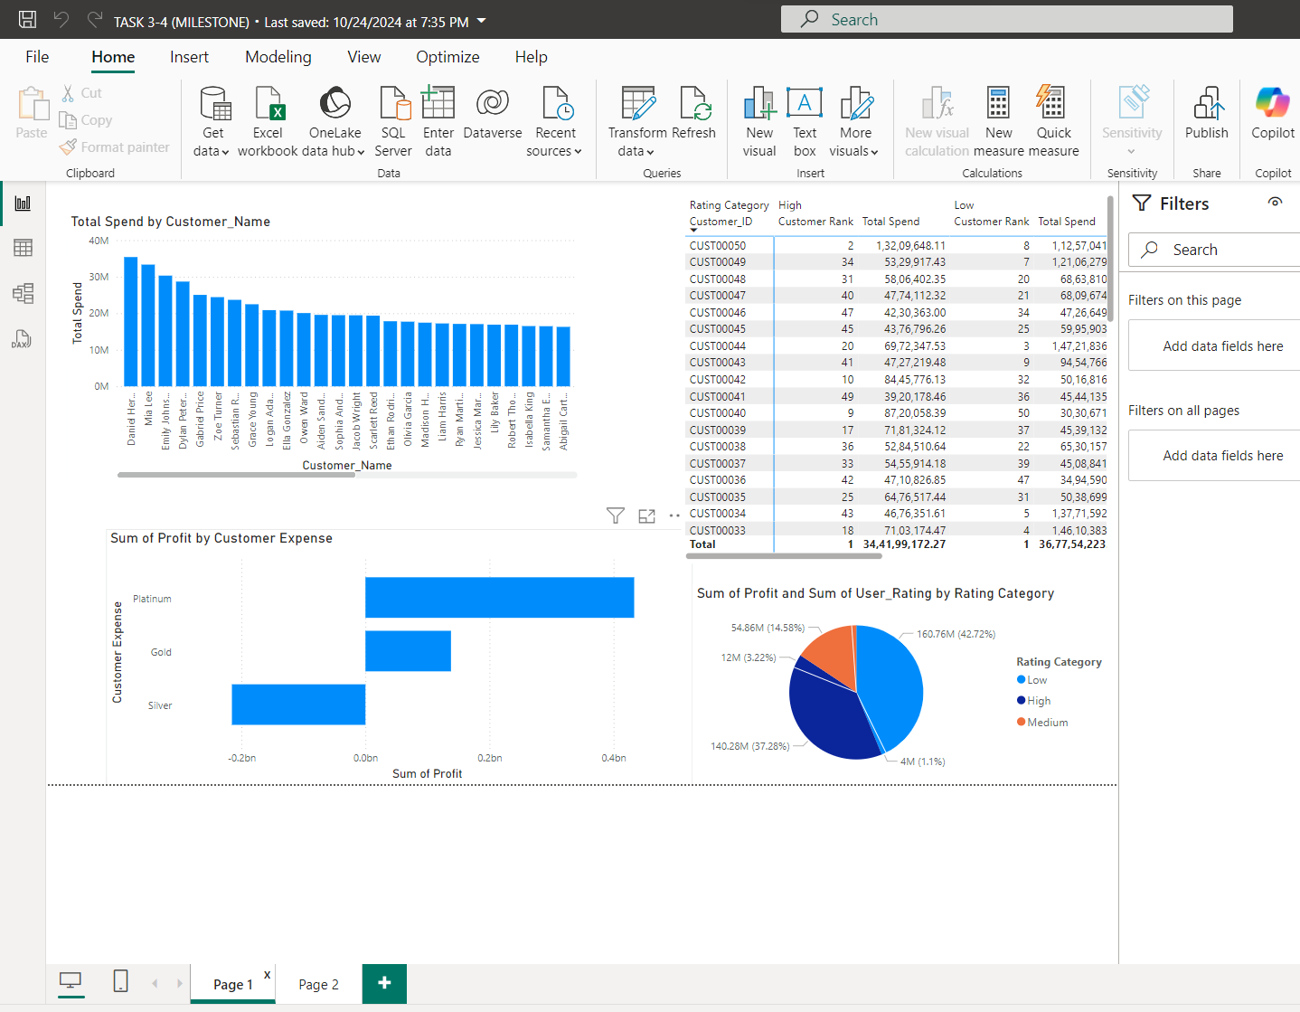

**6. Conclusion**

This analysis provides a structured, data-driven approach to segmenting customers and evaluating product performance. Leveraging Power BI’s DAX capabilities, we generate valuable insights into customer behavior, sales trends, and product popularity, enabling data-driven decisions to enhance customer engagement, optimize inventory, and improve profitability.

**7. Future Work**

Future enhancements may include:

* **Geographical Segmentation**: Analyzing performance by region for localized strategies.
* **RFM Analysis**: Using Recency, Frequency, and Monetary metrics for more granular segmentation.
* **Churn Prediction**: Advanced analytics to predict and prevent customer churn.